**DEEPER LIFE HIGH SCHOOL**

**CULTURAL AND CREATIVE ART SCHEME OF WORK**

JSS 1(BASIC 7) FIRST TERM

**WEEKS TOPIC**

**THEME: ARTS**

1. **Introduction to Art: History; Origin and Types**. i. Definition of Art ii. History and Origin of Arts-Early man
2. **Introduction to Art**: i. Branches of Art i. Textile design ii. Ceramics design iii. Fine Art

(Aesthetic Design)

1. **Types and examples of Craft** i. Meaning of Craft ii. Fabric craft (woven cloth, tie and dye)

iii. Paper Mache iv. Carving craft like sculpture v. Woven craft like iron window, iron gate.

4. **Materials, Tools and different methods used for tie-dye** i. meaning of Tie and Dye ii. Method of tie and dye iii. Materials and tools for tie and dye

5. i. Preparation of dye bath. ii. Dying process.

6. Paper folding techniques

7. **Mid-Term break**

8. Paper Craft Folding Technique: i. meaning of paper craft ii. Materials and tools for making paper crafts iii. Method of folding in paper craft

9. Paper craft production e.g. Kite, Greeting card, Hand fan

10. Revision

11. Examination

**WEEK 1**

**Date…………..**

Topic: INTRODUCTION TO ART (HISTORY/ORIGIN OF ART)

(a)Definition of art

(b)History/Origin of art-Early men

(A) **DEFINITIONS OF ART**

1. Art is a universal language of expression.

2. Art is a means of self-expression of inner feelings or ideas about things, people and the environment in general.

3. Art is the act of making skillful use of materials to produce things for human use and pleasure.

4. Art is the visual and non-visual representation of thought.

5. Art is the skill of doing something, which is not taught.

(B) **History/Origin of art-Early men**

The word art ART originated from a Latin word ‘***ARTI*** ‘ which means-**“to do well”**. Art activities could be traced to the early man, who wrote and drew on cave walls, rock surfaces, Wood and hides. Although most of these materials are aged, weathered and perished.

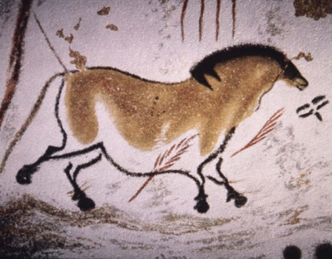 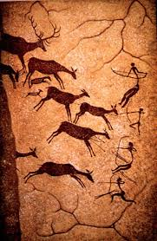

**Techniques Used by the Early Men**

1. Scratching
2. engravings
3. incised drawings
4. graffiti
5. painting

**Tools Used by the Early Men**

These are sharp and hard tools (hunting and farming implements). They include:

1. Sharp stones
2. Bones
3. Wood
4. Ivory

**Materials Used by the Early Men**

1. Animals’ blood
2. Earth colors (clay mixed with animal fat)
3. Colors from plants

Cave art was basically done for ***magical purpose*** for attracting animals which are subsequently killed, and as ***objects of worship***. Such art were discover at Altamira in Northern Spain, Lascaux Cave in Southern France, Tassili and Tibesli Plateau in North Africa.

**EVALUATION**

1. State **three** definition of art
2. Mention two materials used by the early men.
3. Identify three techniques used by the early men.

***REFERENCES***

1. Ibrahim Banjoko (2009) Cultural and creative art made easy *for* schools and colleges Movic Publishing company LTD PP (1-2)
2. Peter Akinyemi (2012) Cultural and creative art for junior secondary school book 1 Sunesis Publishers. Pp(1-2)

**Weekend assignment**

1. The word ART originated from a---------word

(a)Greek (b)Latin (c)Hebrew (d)Yoruba

2 The word “ARTI” means --------

(a)to do well (b)a viewing place (c) to do (d)to eat well

3.---------- is the father of art

a) Akinola Lasekan b) Kenneth murray ( c) Aina Onabolu ( d) Dennise Dureden

4.-------- art was basically done for magical purpose

a) Modern b)cave c)contemporary d)traditional

5. The early men draw on the ------- of his caves

a) well b) wall c) ceiling d) ground

Essay

1. Mention two materials the early men used to draw.

2. Name two tools used by the early men.

3. State three techniques used by the early men.

**WEEK 2**

**Date:…………………………..**

**INTRODUCTION TO ART**

BRANCHES OF ART

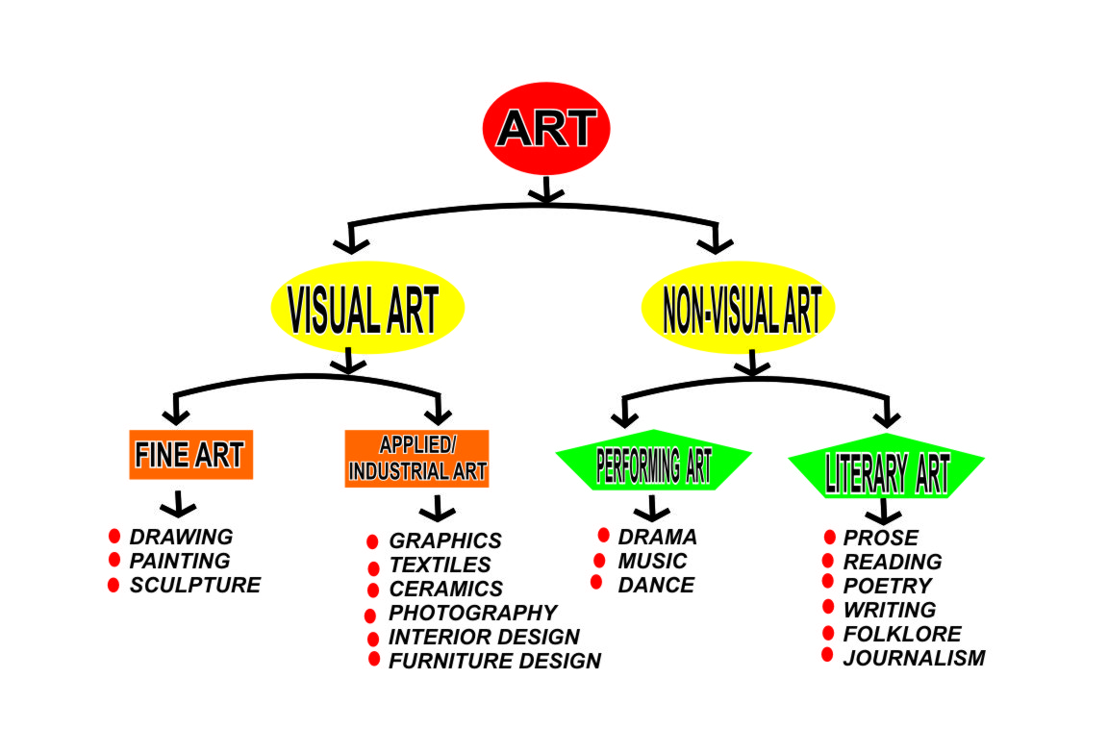

**TEXTILE DESIGN**

Textile design is the art of producing and decorating fabric material using elements of design like colors, and motifs to form design pattern on the fabric.

**Types of Textile Design.**

1. Weaving
2. Embroidery
3. Appliqué
4. Textile print
5. Tie and Dye
6. Batik

**Materials and tools used in Textile design.**

Dye, Caustic soda, Sodium hydro-sulphite, Raffia or twine, candle or wax, starch and alum, Tjanting tool,

**GRAPHICS DESIGN**

It is a commercial art which service our visual communication system in producing designs like Book cover, Poster, greeting cards, 3-dimentional products like bottles and label, packages etc.

Graphic design or graphic art is a method of communication with visual pictures or illustration.

**Example of graphic design**

Advertising and publicity design, Book Illustration, Graphic reproduction, Photography, Cinematography, Industrial Packaging Design.

**Graphic design materials**

Graphic design media/materials are,

1. Pencils 2B, HB, H Series.
2. Pen and Ink
3. Poster color Set
4. Charcoal
5. Fixative
6. Pastel
7. Crayons
8. Tracing paper roll
9. Paper Gum
10. Cartridge Paper

Graphic design tools are:

1. Sable brush
2. Drawing board with T. Square
3. Drawing Table
4. Palette
5. Ruler
6. Set Square
7. Photographic enlarger
8. Tracing board or light box table
9. Calligraphic pens.
10. Masking tape and cellotape
11. Computer.

**CERAMIC DESIGN**

Ceramic design is the art of producing wares or articles like Pot, Jug, Cup, Plates, Sanitary wares, porcelain, bricks and tiles and pottery.

**Ceramic tools**

1. Spatula 8. Slip trainer
2. Wire tools 9. kiln
3. Lines gouged 10 Potter’s wheel
4. Brushes 11. String
5. Rolling-pin 12. Table plastic container
6. Damped cloth 13 Cellophane
7. Sponge

**Ceramic media/material**

1. Clay
2. Glaze
3. kaolin

**FINE ART (Aesthetics Design)**

Aesthetic design is the creation of the art works that are concern with beauty or having a pleasing appearance. It is majorly for beautification and decoration purposes.

Examples are Painting, Drawing, Sculpture, Architectural design work

**EVALUATION**

1. What is Graphic design?
2. State five materials and five tools used in Graphics
3. What is Aesthetic design?

**WEEKEND ASSIGNMENT**

1. Element of design needed in a Textile design is­­­­­_________
2. Colour B. painting C. Packaging D. Advertising
3. One is not true of types of Textile design.
4. Weaving B. Embroidery C. Textile Print D. Graphic Design.
5. ______ art is a method of communication with visual pictures or illustration.
6. Graphics B. Textile C. Ceramics D. Labeling Packaging.
7. Example of Graphic design include all except _________
8. Book illustration B. Photogr aphy C. Advertising D. Embroidery.
9. _______ is the art of producing Wares.
10. Ceramic design B. Package design C. Cinematography D. Industrial package design.

**WEEK 3**

**TOPIC: TYPES OF CRAFT**

1. Meaning of craft
2. Fabric craft
3. Paper craft
4. Carving craft
5. Woven craft

**Meaning of craft**

Crafts are manually produced objects meant to serve a particular purpose of human needs. They can also be called handicraft. This is so because the use of skilled hand is involved. They are usually produced with local materials. The person who makes craft is known a craftsman.

**Fabric craft**

These are crafts done with fabric material. It is also known as textile production. Methods of production could be by printing, weaving, tie & dyeing, batik and embroidery. Materials involve include fabric, loom, dye, textile ink, sewing machine, wax etc. Examples include

1. woven clothes (aso-oke),
2. tie-dye design,
3. textile prints (Nigerian wax),
4. Fashion design,
5. Appliqué
6. Embroidery
7. Batik

Fabric crafts are common in Iseyin, Abeokuta, kano, Osogbo, Akwete, Adinkra and kente in Ghana.

**Paper Craft**

This is the shaping or building prototype of different geometric or basic shapes and sizes to form cuboids, pyramids, abstract sculptural figures etc. Some of these crafts involve the use of pulp mixed with starch.

Materials involve include scissors, ruler, pencil, water, starch and rope.

Examples of Paper Craft are:

1. Paper folding
2. Making kite
3. Papier-mâché

**EVAUATION**

1. Define craft.
2. Name 2 types of craft.
3. List five examples of fabric craft.
4. Mention three examples of paper craft.

**Carving Craft**

Carving is the process of cutting away parts of a media to achieve a particular form. Carving crafts are done on wood, ivory thorns, stones and calabash, while some are used for decoration, and others serve as functional materials for human utility. Carving tools and materials include chisel, cutter, adze, sandpaper, wood, ivory, thorns, stones and calabash.

These crafts are notable in places like Oyo, Benin and Esie in kwara state.

Examples of carving craft include:

1. Wood carving
2. Calabash carving
3. Thorn carving
4. Ivory carving
5. Stone carving

**Woven Craft**

Woven crafts are artworks done through weaving process. Weaving is the interlacing of yarn, raffia and cane to make useful and functional materials.

Examples include

1. macramé
2. cloth weaving
3. basket weaving
4. mat weaving
5. cane weaving.

Woven craft is highly appreciated in the society.

**Molded Craft**

The art of building objects with materials like clay, plasticine, Papier-mâché.

Example include

1. Ceramic wares

**Uses of Craft**

1. For beautification
2. For utility purposes.
3. For promoting culture and tradition.
4. For income generation.

EVALUATION

1. What is carving?
2. List 2 materials used in carving craft.
3. Mention 4 types of craft.
4. Give 3 examples of fabric
5. State 4 uses of craft.

READING ASSIGNMENT

T. Sola, et al Cultural and creative art ( Comprehensive text on music, fine art & drama for JSS-Basic 9)page

WEEKEND ASSIGNMENT

1. --- are manually produced objects meant to serve a particular purpose of human needs (a) drawing (b) dance (c) craft (d)drama
2. Which of the following is not a type of craft? (a) carving (b) graphics (c) tie and dye (d) weaving
3. One of these materials is not used for paper folding technique (a) scissors (b) ruler (c) pencil (d) basket
4. One of these is a product of woven craft (a) basket (b) shoe (c) banner (d) cutlass
5. Chisel is one of the tools for__ (a) drawing (b) painting (c) printing (d) carving
6. One of the following is not a craft (a) painting (b) carving (c) tie and dye (d) blacksmithing
7. Which of these is a product of molded craft? (a) kite (b) clothe (d) calabash
8. Jewelries are craft used for __ (a) building (b) reading (c) demonstration (d) decoration
9. Which of these craftworks cannot be used to promote culture? (a) kite (b) walking stick (c) water pot (d) adire cloth

ESSAY

1. Define craft
2. State 4 media for carving
3. Give 3 examples of paper craft.
4. State 2 uses of craft.

**WEEK 4**

**TOPIC: TIE AND DYE**

1. Meaning of tie and dye.
2. Method of tie and dye
3. Tie and dye locations in Nigeria

Tie and dye is the process of decorating or creating patterns on fabric materials through tying, stitching, clamping or any other method in order to resist the absorption of dye solution.

METHODS OF TIE AND DYE

Methods in tie –dye depend heavily on the tying techniques.

1. Pleating
2. Twisting
3. Knotting
4. Stitching
5. Clamping
6. Spiral tying
7. Marbling
8. Pouring
9. Folding
10. Triangular sandwitching
11. Pebbling
12. Pick and tie

LOCATION

1. KANO- pit dyeing
2. ABEOKUTA- batik process
3. OSOGBO- indigo dyeing

EVALUATION

1. Define tie and dye.
2. Name 4 methods of tie and dye.
3. List 3 locations of tie and dye in Nigeria.

**SPIRAL TYING METHOD** This is a method in which one end of the fabric is first tied to a point and the other end is held and rolled in spiral form.

**MARBLING METHOD** It is a method of decorating fabric with a pattern that looks like marble.

**STITCHING** This is a method by which a needle, thread or raffia used to stitch a fabric alternatively before dyeing.

**POURING METHOD** In this method the fabric is first soaked in cold water, gently squeeze excess water and laid on a clean flat surface. Some areas are then picked to form hill shapes. Then pour the prepared dye on each of the hill shape little by little while it spread down the hill shape to areas without hills.

**PLEATING** It is a method in which a permanent fold in the fabric, made by sewing on top or side of the fold.

**COCKING METHOD** This is a method by which bottle corks are put round or under the fabric one after the other and tied tightly.

**KNOTTING** This is the method by which a fabric meant for dyeing is tied to form knots in a chosen pattern.

**CLAMPING** It is a method by which the chosen fabric is held together tightly and tied by clamps.

MATERIALS AND TOOLS FOR TIE AND DYE.

The materials are consumable items and they include

i. 100% clean cotton fabric

ii. string rope or raffia

iii. dyes, pigment of different colours.

iv. chemicals include (caustic soda ,hydro-sulphite)

v. salt: it serves as fixatives.

The tools are solid objects that cannot be consumed, they include

i. plastic bowls; It serves as dye bath.

ii. rubber gloves; to protect hand.

iii. stick to stir dye baths

iv. spoons for measuring dye

v. press iron for finishing

EVALUATION

1. Spoon is used for measuring (a)dye only (b)fabric (c)caustic soda dye, hydrosulphite. (d)water.
2. Gloves are used for the ……….. during dyeing (a)fingers (b)hands (c)skin (d)eye

ESSAY

1. Define materials and tools
2. List various materials and tools used for tie dying and their uses.
3. Explain the following methods of tie and dye
4. Marbling
5. Clamping

**READING ASSIGNMENT**

LOWO A. DAVID (2012) Eraz cultural & creative Art for JSS 1 Pages 57-62

WEEK 5**.**

**TOPIC: PREPARATION OF DYE BATH**

i. Preparation of dye bath.

ii. Dyeing process

1. PREPARATION OF DYE BATH. This involves setting up objects which can be used for dyeing process. The dye bath here refers to a pit filled with dye substance or a big bowl for dyeing .The dye pit is prepared when the necessary mixture are in the dye bath e.g dye, water, caustic soda, hydro-sulphite, salt.

II. DYING PROCESS.

1. The fabric to be dyed must be clean; you do this by washing the fabric with water.

2. Plan your design by tying cloth in any combination.

3. Prepare your dye bath.

4. Dip cloth in dye solution and stir constantly with stick so that the material will be dyed evenly or using hand /rubber gloves to protect your hand.

5. Leave the material in dye bath for about 40 minutes.

6. Remove from dye and Hang for oxidation for 10 minutes.

7. Rinse in cold water

If another colour is to be used, untied the strings desired, re-tie at other sports and put in another colour of dye solution. Start with the lightest colour and end with the darkest e.g. yellow should come before blue, orange before purple and so on.

Allow to drip dry or squeeze out excess water.

Press cloth with iron when cloth is still damp to also help set the colour.

EVALUATION

.1. The two chemicals used with the dye stuff are:

a. Sulphuric acid and chlorine

b. Turpentine and glaze

c. Caustic soda and sodium sulphite

d. Sodium hydrosulphite and fixative

2. Why is it necessary to put on rubber gloves during dyeing exercise?

a. To prevent the damaging actions of the chemicals on the skin

b. To make the turning of the cloth easier

c. To make the cloth absorb easier

d. To make dye solution cover the materials well

3. Dye stuff are

a. Mixture of some chemicals

b. Substances obtained from some plants and processed into several colour

c. Products of some fruits juice

d. Combination of water colour and oil colour

4.Which is the best order in decorating fabric in more than one colour?

a. Green, yellow, violet

b. Yellow, violet, green

c. Violet, green, yellow

d. Yellow, green, violet

5. What is the usefulness of sodium hydrosulphite in dyeing process?

a. To make the dye stuff brighter in colour

b. To enable the whole mixture blend well

c. For easy absorption and quick action on fabric

d To make dye remain permanent on fabric or much longer

6. Which of these help to resist dye on fabric in the batik process?

a. Rubber thread or twine

b Gum Arabic or lip stick

c. Cassava and starch or hot wax

d. Grease or pomade

7. The first thing to be done in dying process is (a) mix the dye (b) tie fabric (c) wash fabric (d) Rinse fabric

8. One of the following is not a material for tie and dye (a) fabric (b) twine (c) dye (d) wax

**THEORY.**

1.Why is the dye bath needed in the tie dye process?

2.State the various steps involved in dyeing process.

**WEEK 6.**

**Paper craft folding technique.**

Meaning. Materials and tools. Process or steps. Uses. Safety measures

MEANING OF PAPER FOLDING TECHNIQUES

Paper folding techniques means shaping or building prototype of different geometric or basic shapes and sizes to form cuboids, pyramids, abstract, sculptural figures etc.

MATERIALS AND TOOLS

The basic materials for paper folding techniques includes:

a. Chipboard

B. Cardboard,

C. Strawboard,

D. Embossed card,

E. Drawing sheet,

F. Brown paper

G. Adhesive (glue or gum).

H. Pencil

***The basic tools include***:

i. Instruments for cutting (razor blade, cutter, scissors) others are

Ii. Ruler or compass

1. Measuring tape.

EVALUATION.

1. Define paper folding technique .
2. Mention five materials that can used in paper craft technique

PROCESS OF PAPER FOLDING

The type of model to be constructed determines the method and materials to be used, this is because the method for constructing a building model (prototype) is different from the one for constructing pyramid or cuboid.

FOLDING A CUBOID

Cuboids are solid objects with six rectangular sides that stand at right angle to one another. This can be got by assembling two cubes side by side. ( a cube is a solid with six equal sides and all its angles are at right angle)

*Step 1*: Sketch the object you desire on a piece of cardboard as shown below. Make sure all the six squares are equal. (it will be good to create flaps on the sides of section 1 of the squares to help for easy pasting of the adhesive)

*Step 2:* cut out the drawing

*Step 3:* fold the cardboard along the dotted lines to form a square shape

*Step 4;* open the square cardboard to form a cube

*Step 5:* now use adhesive (glue, gum) to join the wings together. (You can easily apply the adhesive on the flaps)

*Step 6:* produce as many cuboids as possible like six or eight and gum them together in a creative manner as you desire.

DIAGRAM

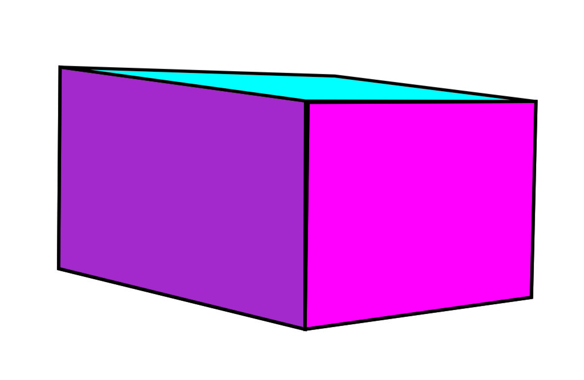

A cuboid

USES OF PAPER FOLDING TECHNIQUES

1. It develops the students’ accuracy.
2. It develops sense of harmony in the student.
3. It helps in the basic training of anything construction.
4. It is used for structural composition
5. It is used for the production of learning materials such as three-dimensional objects/design.
6. It develops a sense of creativity in students

SAFETY MEASURES

1. Avoid the use of razor blades, use scissors or cutter
2. Measure accurately to prevent waste of materials

EVALUATION

1. Mention five uses of paper folding techniques
2. What are the safety measures in paper folding technique

WEEKEND ASSIGNMENT

Create a composition of different forms that are stuck together using the paper folding technique.

**WEEK 7**

**Mid-term break**

**WEEK 8**

**Paper craft production (practical)**

Produce the following

1. KITE
2. GREETING CARD
3. HAND FAN

**WEEK 9 REVISION**

**WEEK 10 EXAMINATION**